**DATABASE -MYSQL DAY1 TASK**

Exercise 1 — Tasks

1. Find the title of each film

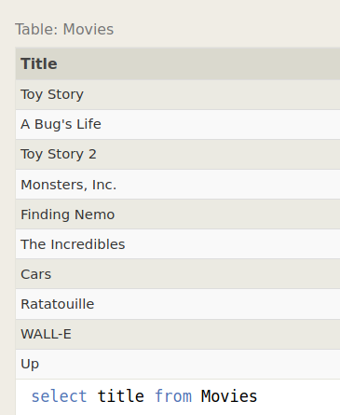

1. Find the director of each film

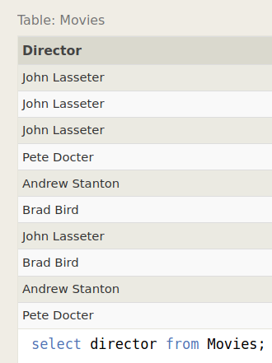

1. Find the title and director of each film

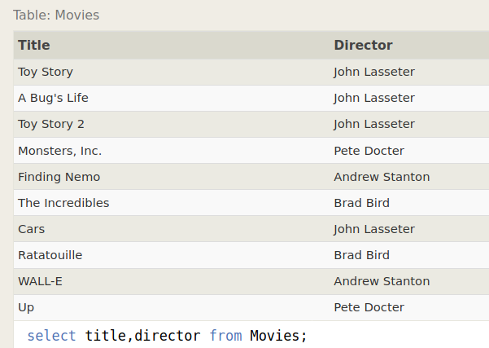

1. Find the title and year of each film

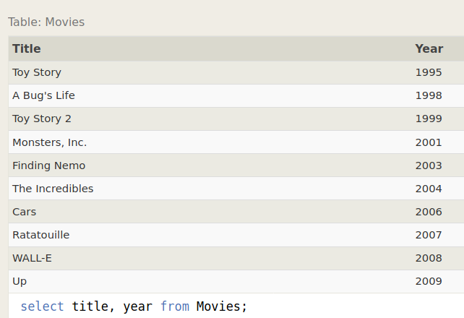

1. Find all the information about each film

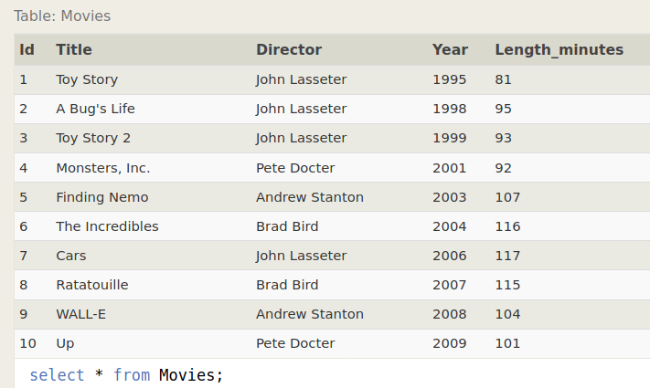

Exercise 2 — Tasks

1. Find the movie with a row id of 6

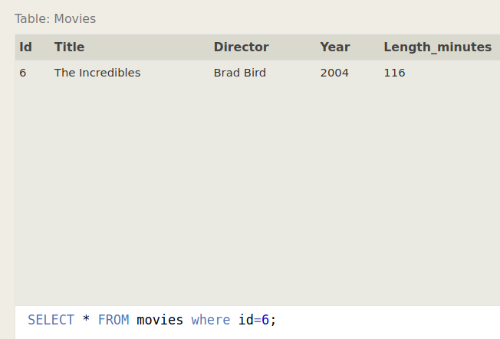

1. Find the movies released in the years between 2000 and 2010

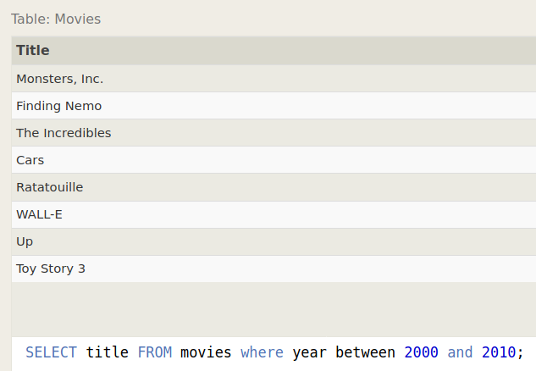

1. Find the movies **not** released in the years between 2000 and 2010

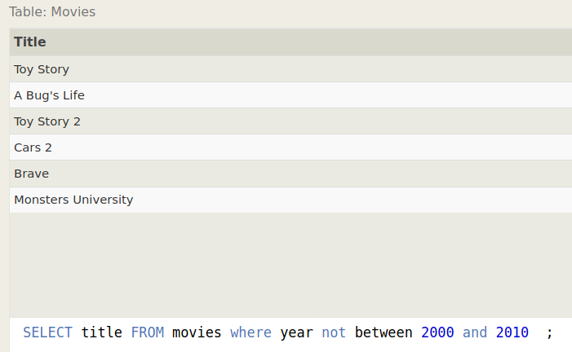

1. Find the first 5 Pixar movies and their release year

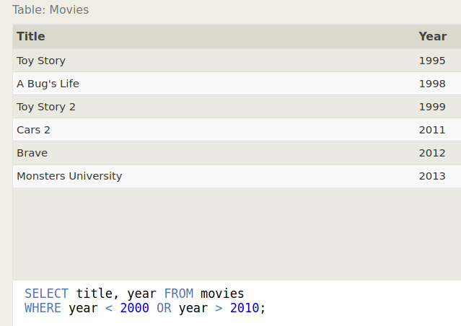

Exercise 3 — Tasks

1. Find all the Toy Story movies

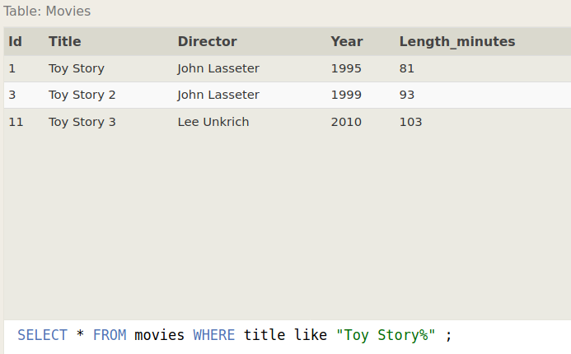

1. Find all the movies directed by John Lasseter

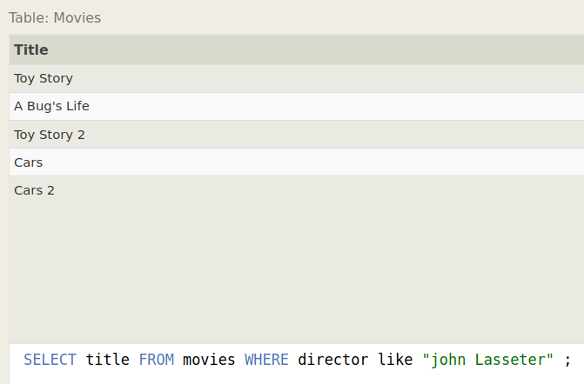

1. Find all the movies (and director) not directed by John Lasseter

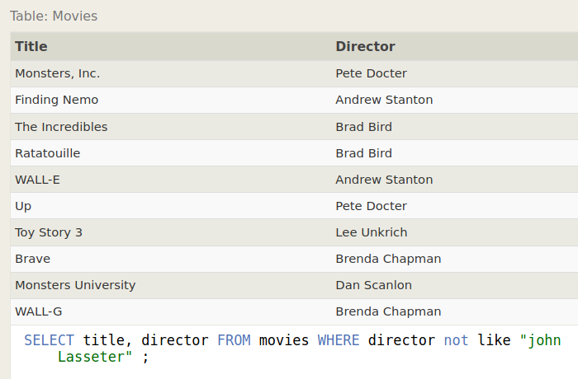

1. Find all the WALL-* movies

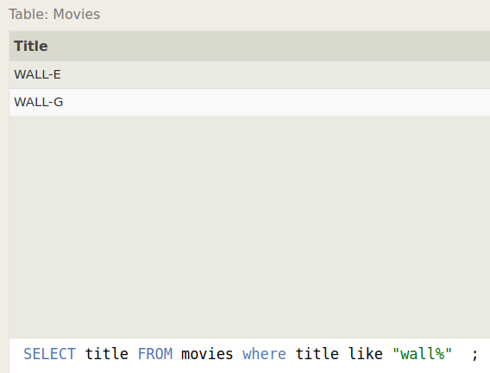

Exercise 4 — Tasks

1. List all directors of Pixar movies (alphabetically), without duplicates

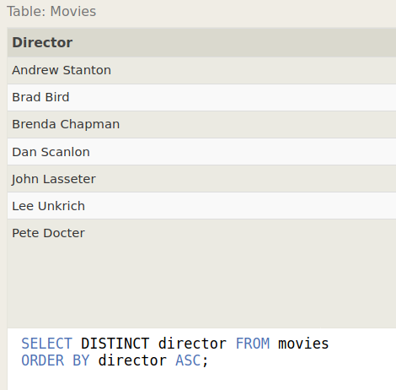

1. List the last four Pixar movies released (ordered from most recent to least)

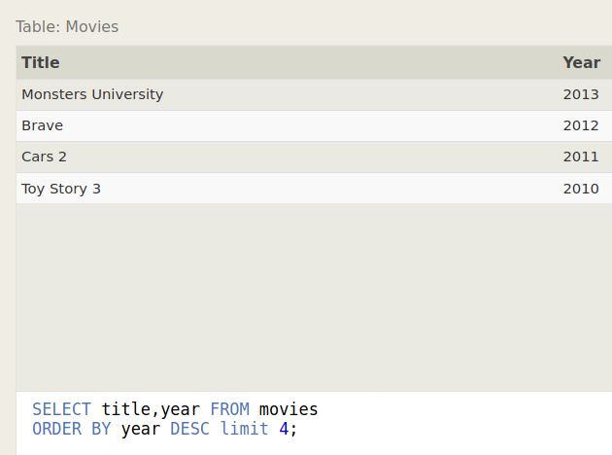

1. List the **first** five Pixar movies sorted alphabetically

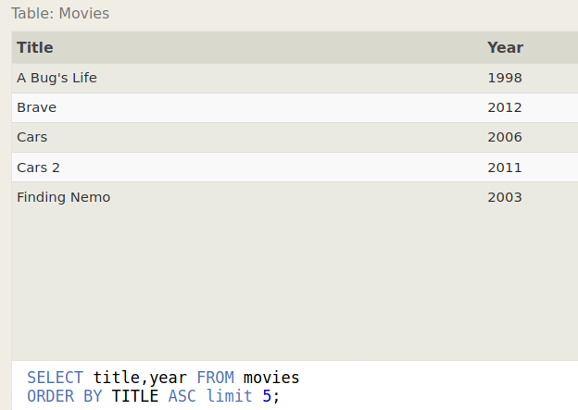

1. List the **next** five Pixar movies sorted alphabetically

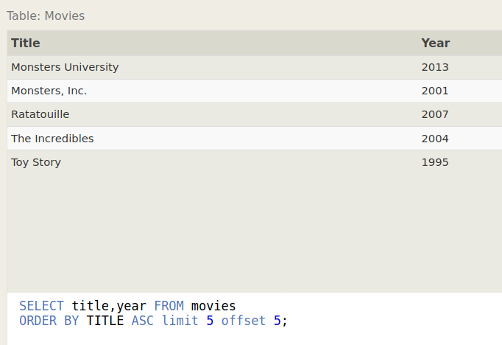

Review 1 — Tasks

1. List all the Canadian cities and their populations

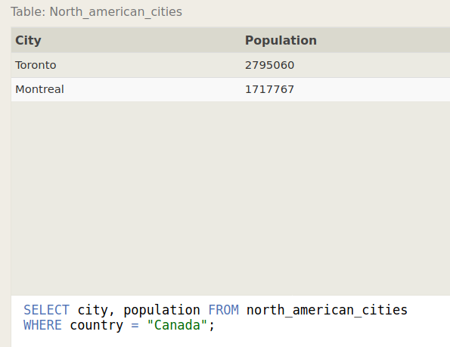

1. Order all the cities in the United States by their latitude from north to south

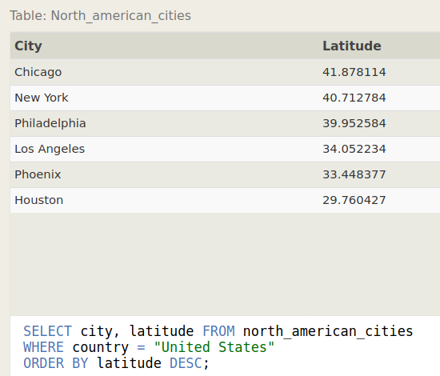

1. List all the cities west of Chicago, ordered from west to east

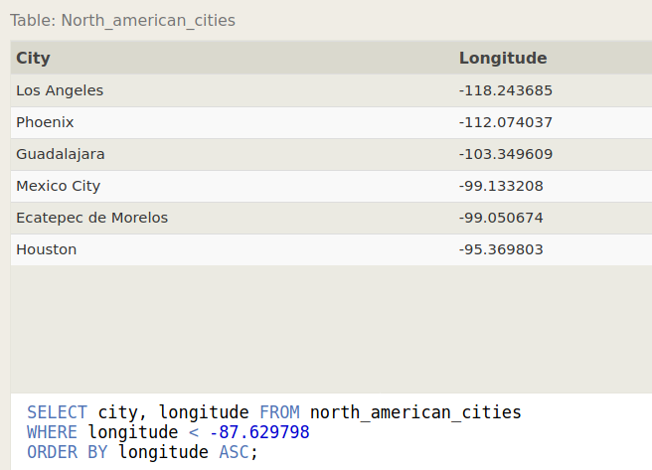

1. List the two largest cities in Mexico (by population)

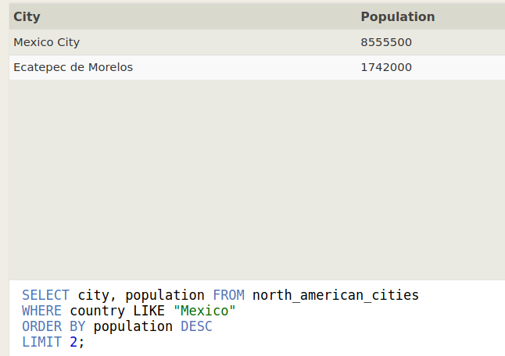

1. List the third and fourth largest cities (by population) in the United States and their population

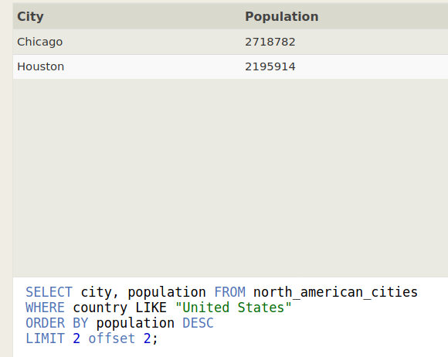

Exercise 6 — Tasks

1. Find the domestic and international sales for each movie

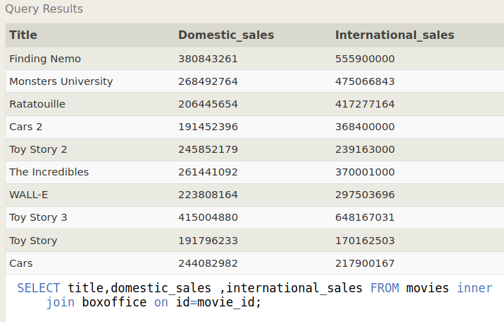

1. Show the sales numbers for each movie that did better internationally rather than domestically

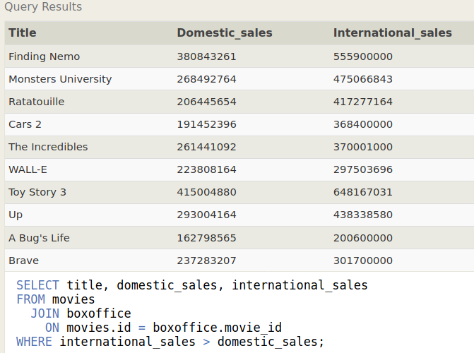

1. List all the movies by their ratings in descending order

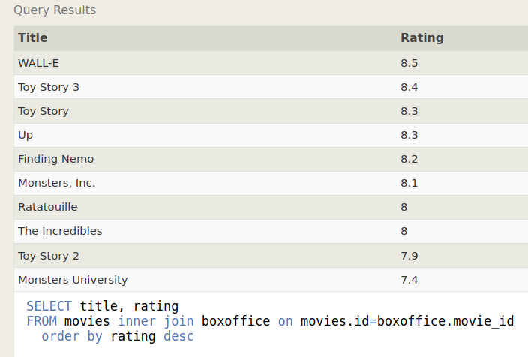

Exercise 7 — Tasks

1. Find the list of all buildings that have employees

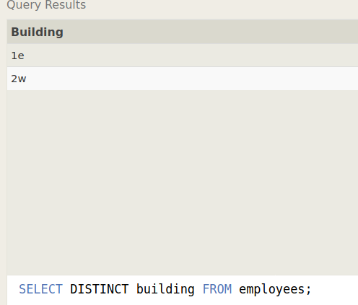

1. Find the list of all buildings and their capacity

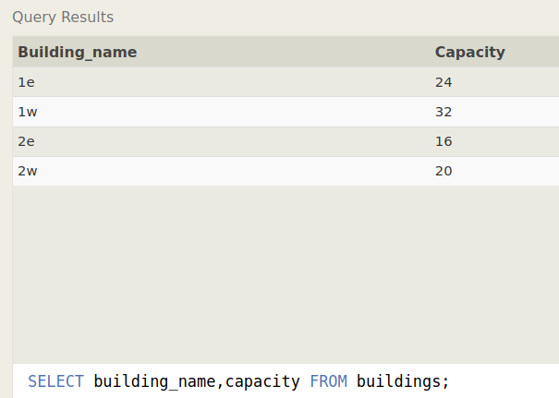

1. List all buildings and the distinct employee roles in each building (including empty buildings)

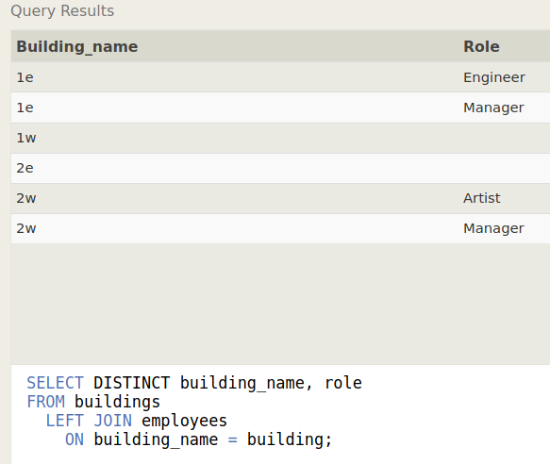

Exercise 8 — Tasks

1. Find the name and role of all employees who have not been assigned to a building

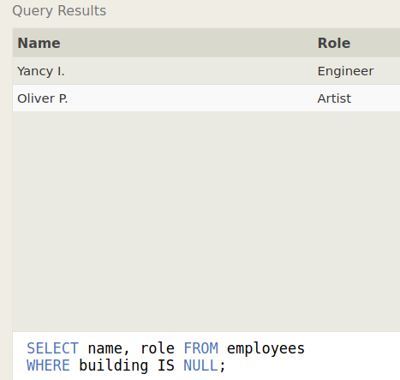

1. Find the names of the buildings that hold no employees

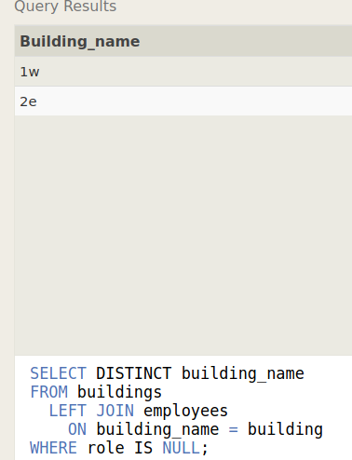

Exercise 9 — Tasks

1. List all movies and their combined sales in **millions** of dollars

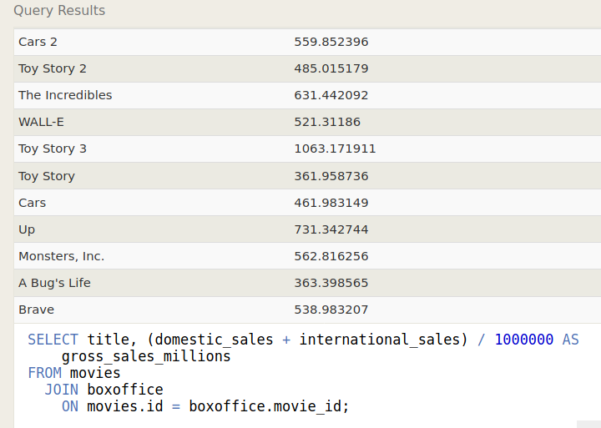

1. List all movies and their ratings **in percent**

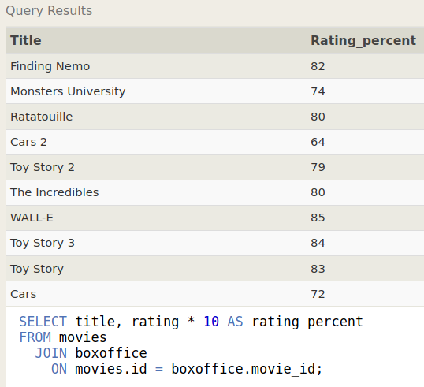

1. List all movies that were released on even number years.

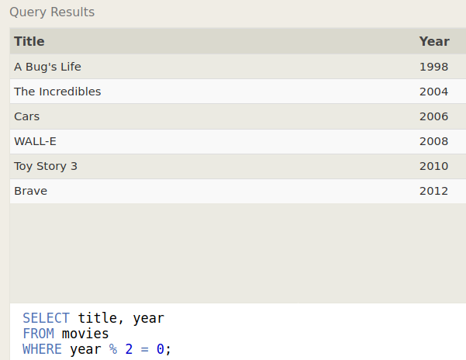

Exercise 10 — Tasks

1. Find the longest time that an employee has been at the studio

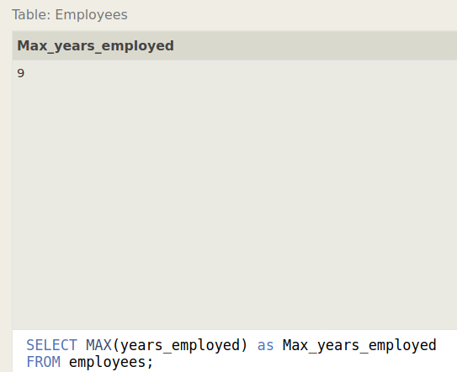

1. For each role, find the average number of years employed by employees in that role

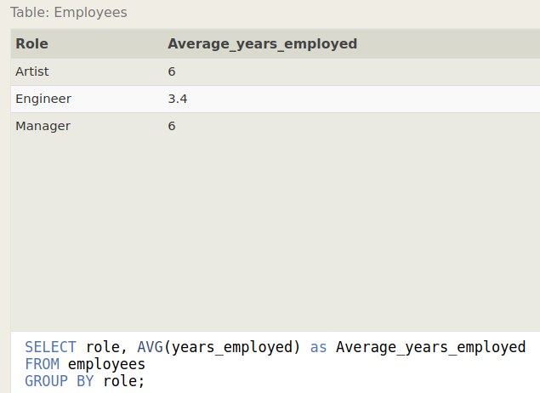

1. Find the total number of employee years worked in each building

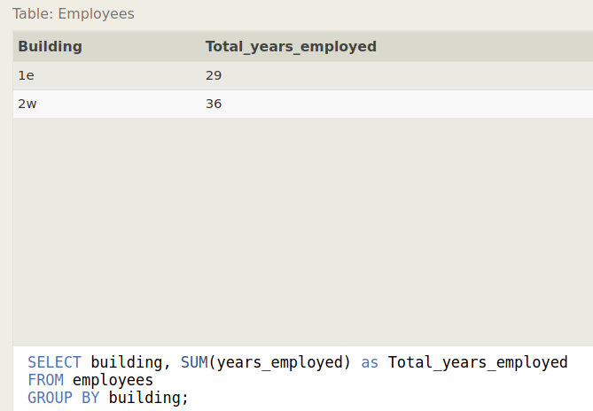

Exercise 11 — Tasks

1. Find the number of Artists in the studio (without a **HAVING** clause)

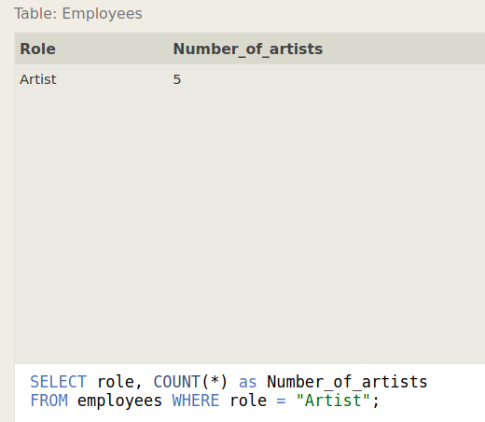

1. Find the number of Employees of each role in the studio

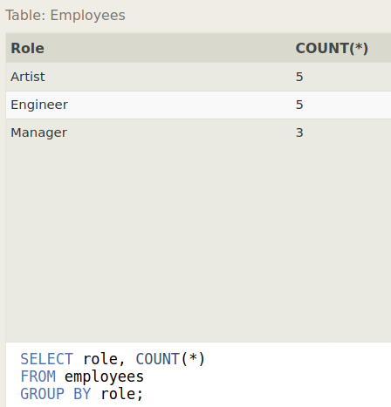

1. Find the total number of years employed by all Engineers

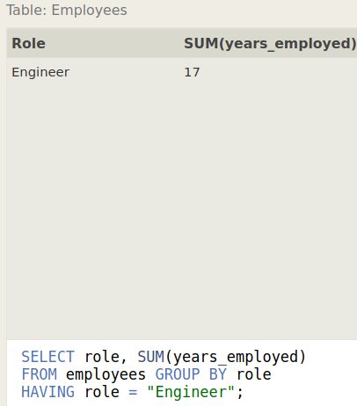

Exercise 12 — Tasks

1. Find the number of movies each director has directed

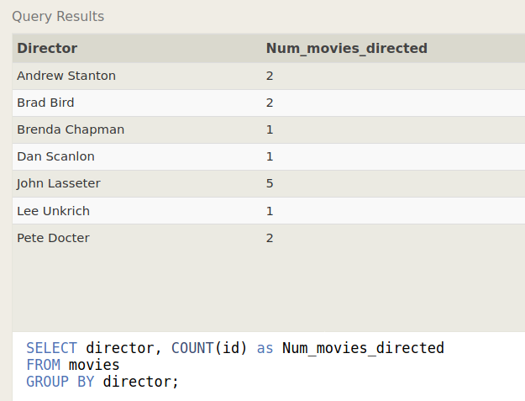

1. Find the total domestic and international sales that can be attributed to each director

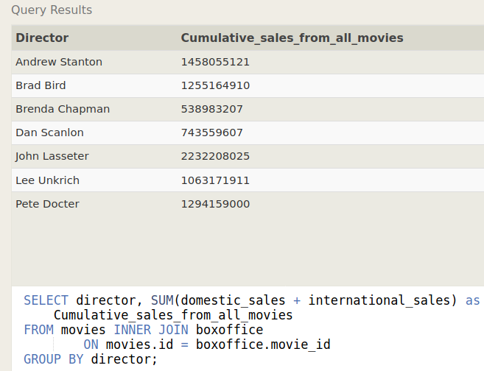

Exercise 13 — Tasks

1. Add the studio's new production, **Toy Story 4** to the list of movies (you can use any director)

**UPDATE movies SET year = 1999 WHERE id = 3;**

**Output**

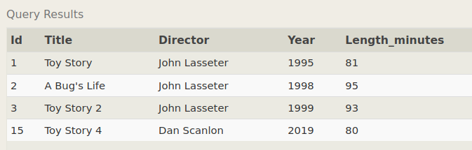

1. Toy Story 4 has been released to critical acclaim! It had a rating of **8.7**, and made **340 million domestically** and **270 million internationally**. Add the record to the BoxOffice table.

**INSERT INTO boxoffice VALUES (4, 8.7, 340000000, 270000000);**

**Output**

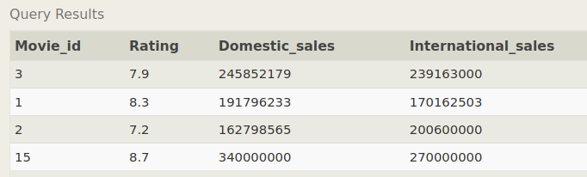

Exercise 14 — Tasks

1. The director for A Bug's Life is incorrect, it was actually directed by **John Lasseter**

**UPDATE movies SET director = "John Lasseter" WHERE id = 2;**

**Output**

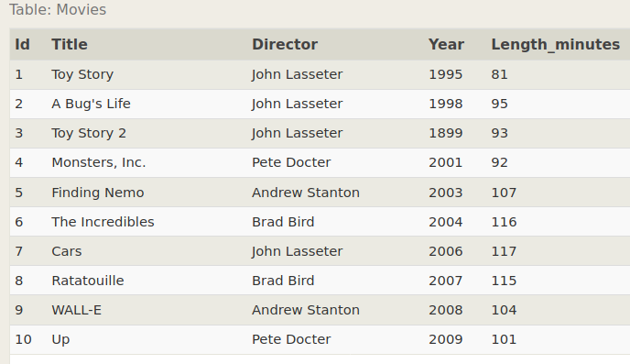

1. The year that Toy Story 2 was released is incorrect, it was actually released in **1999**

**UPDATE movies SET year = 1999 WHERE id = 3;**

**Output**

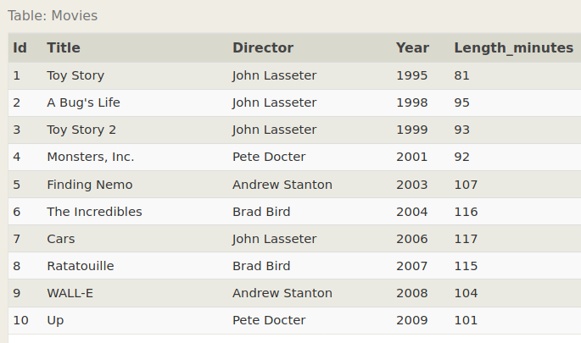

1. Both the title and director for Toy Story 8 is incorrect! The title should be "Toy Story 3" and it was directed by **Lee Unkrich**

**UPDATE movies SET title = "Toy Story 3", director = "Lee Unkrich"**

**WHERE id = 11;**

**Output**

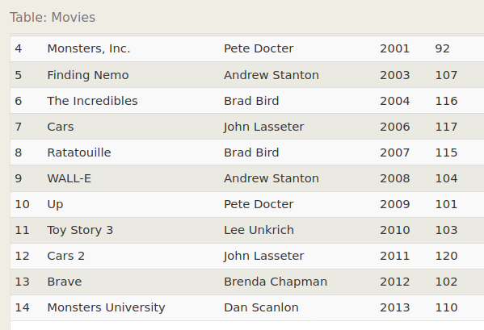

Exercise 15 — Tasks

1. This database is getting too big, lets remove all movies that were released **before** 2005.

**DELETE FROM movies where year < 2005;**

**Output**

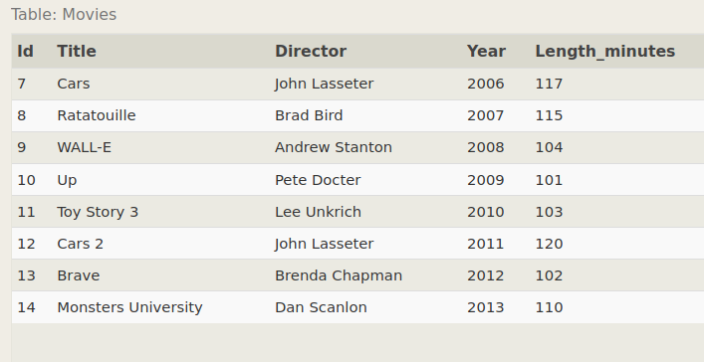

1. Andrew Stanton has also left the studio, so please remove all movies directed by him.

**DELETE FROM movies where director = "Andrew Stanton";**

**Output**

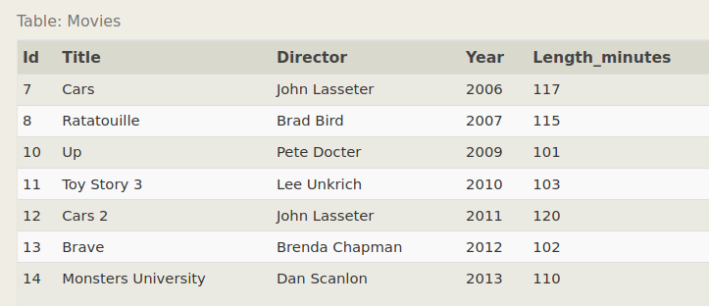

Exercise 16 — Tasks

1. Create a new table named Database with the following columns:  
     
    – Name A string (text) describing the name of the database  
    – Version A number (floating point) of the latest version of this database  
    – Download_count An integer count of the number of times this database was downloaded  
     
    This table has no constraints.

**CREATE TABLE Database (Name TEXT, Version FLOAT, Download_count INTEGER);**

**Output**

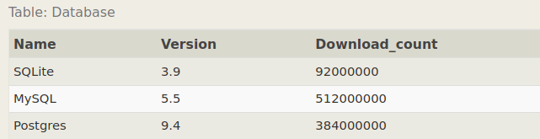

**Exercise 17 — Tasks**

1. Add a column named Aspect_ratio with a FLOAT data type to store the aspect-ratio each movie was released in.

**ALTER TABLE Movies ADD COLUMN Aspect_ratio FLOAT DEFAULT 2.39;**

**Output**

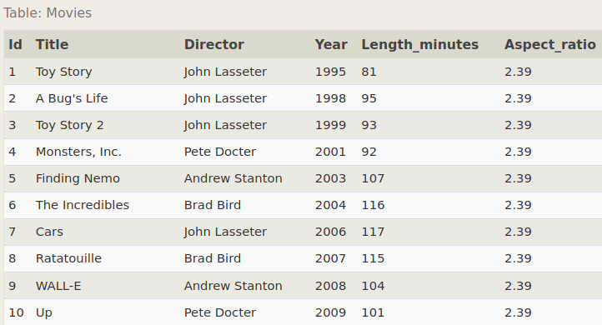

1. Add another column named Language with a TEXT data type to store the language that the movie was released in. Ensure that the default for this language is English.

**ALTER TABLE Movies ADD COLUMN Language TEXT DEFAULT "English";**

**Output**

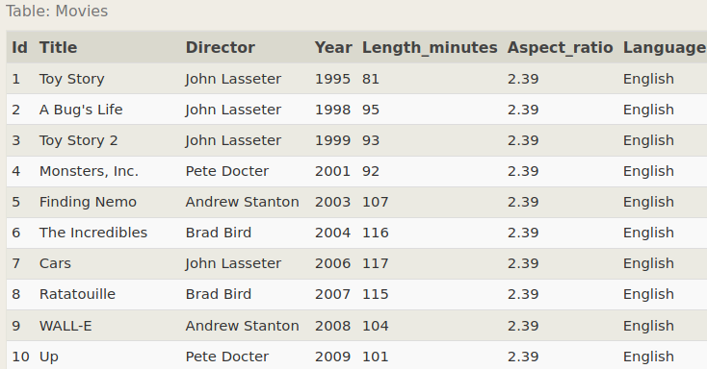

**Exercise 18 — Tasks**

1. We've sadly reached the end of our lessons, lets clean up by removing the Movies table

**DROP TABLE Movies;**

**Output**

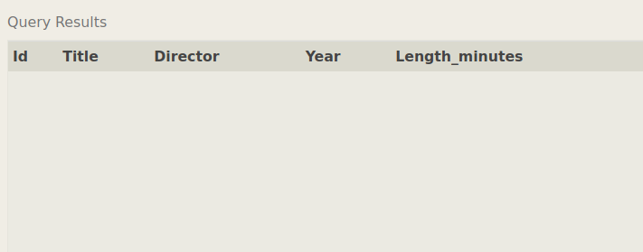

1. And drop the BoxOffice table as well

**DROP TABLE BoxOffice;**

**OUTPUT**

